# CHAPTER 8: CONNECT TO A MESSAGING PROVIDER

## Theory

WebSphere Application Server supports asynchronous messaging that allows to create, send, receive and read requests. Asynchronous messaging support is based on Java Message Service (JMS) and Java EE Connector Architecture (JCA).

Synchronous messaging requires both applications to be available at the same time as in the example of phone talk. On the other hand, asynchronous messaging doesn’t require sending and receiving applications available at the same time. We can use postal service as an example.

Java Message Service (JMS) is a Java API to access to message providers. JMS provider or in other words messaging provider gives the basis for the exchange of messages between applications.

A JMS message consist of three parts;

* Header, must exist in every JMS message and it is assigned automatically mostly by JMS provider when the message put to a JMS destination.
* Properties, are optional and can be application related, provider related and standard properties. Properties provide an efficient mechanism to filter application defined messages.
* Body, contains the main information which needs to be exchanged.

There are 6 different types of JMS messages based on the data it contains:

* Message, it is the base class and used for event notification.
* BytesMessage, stores the data as sequence of bytes and used for exchanging data in a format that is native to the application.
* TextMessage, stores the data as a string and used for simple text message exchanging.
* StreamMessage, stores the data as a sequence of primitive Java types.
* MapMessage, stores the data as a set of key-value pairs and used for delivering keyed data that can change in different messages.
* ObjectMessage, stores a serialized Java object and used for Java object exchanging.

XML (Extensible Markup Language) is mostly used format in Java applications. It allows you to describe the data independent of the language that the application is written in or the platform which the application runs on.

A service integration bus is a group of servers or clusters that cooperate to provide asynchronous messaging service. An application server or a cluster can be a member of a bus. With service integration bus

* Any application can exchange messages with any application using destination.
* A message producing application can produce messages for a destination regardless of the messaging engine that the producer uses to connect to the bus.
* A message consuming application can consume messages from a destination regardless of which messaging engine the consumer uses to connect to the bus.

A connection factory is an object that is used by JMS client to establish the connection to a JMS provider. It is stored and managed object in a JNDI namespace. A connection factory can create connections to one messaging provider only. If you need to connect to a different provider, you need to create a new connection factory.

A JMS destination is an object that can be a JMS queue or a JMS topic. It represents the target of messages the client produces and the source of messages that the client consumes.

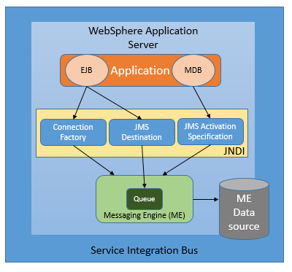

JMS activation specification is the standard way to manage the relation between Message-driven beans (MDB) which are a special class of Enterprise Java Beans (EJB) and a messaging engine.

## AIM

In this lab exercise, you will configure default messaging provider in WebSphere Application Server to enable the communication between applications that run on the application server and the other applications.

In order to achieve this, you need to complete following steps:

1. Create a Service Integration Bus
2. Configure JMS connection factory
3. Add a Bus member
4. Configure JMS destination
5. Configure JMS queue
6. Configure JMS Activation Specifications

# Lab Exercise 8: CONNECT TO A MESSAGING PROVIDER

|  |
| --- |
| Create SIB  Connect. Factory  BUS member  JMS Dest.  JMS Queue  JMS  AP |

## Create a Service Integration Bus

## Configure JMS connection factory

## Add a Bus member

## Configure JMS destination

## Configure JMS queue

## Configure JMS Activation Specifications

Create SIB

Connect. Factory

BUS member

JMS Dest.

JMS Queue



JMS   
AP

**Task 1: Create a Service Integration Bus**

**Step 1:** Navigate to “Service integration>Buses” and then click on “New” to add a new bus.

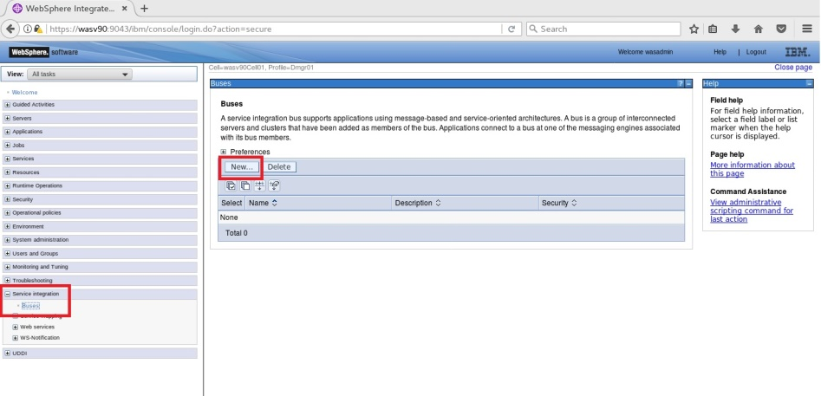

Create SIB

Connect. Factory

BUS member

JMS Dest.

JMS Queue



JMS   
AP

**Step 2:** You need to enter the name for the new bus, eg. “FC_SampleBus” and then click “Next”.

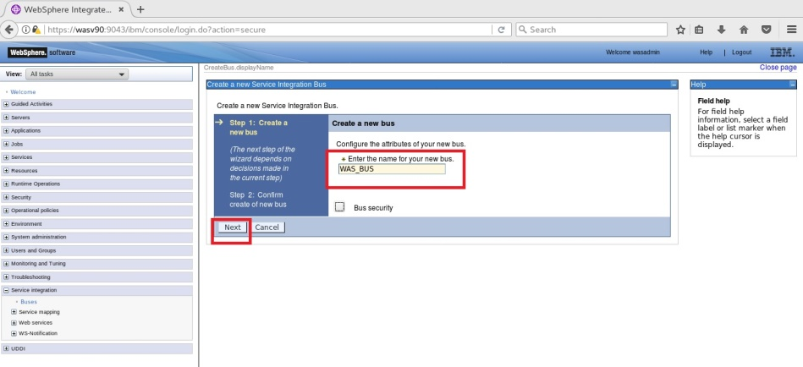

**Step 3:** Review the summary of actions and click “Finish”.

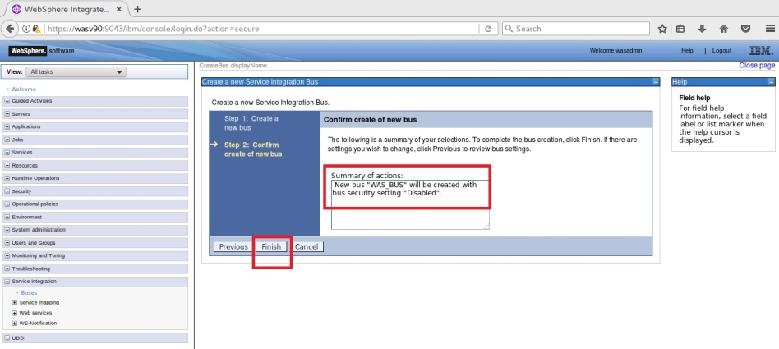

Create SIB

Connect. Factory

BUS member

JMS Dest.

JMS Queue



JMS   
AP

**Step 4:** Click on “Save” to write the changes directly to the master configuration.

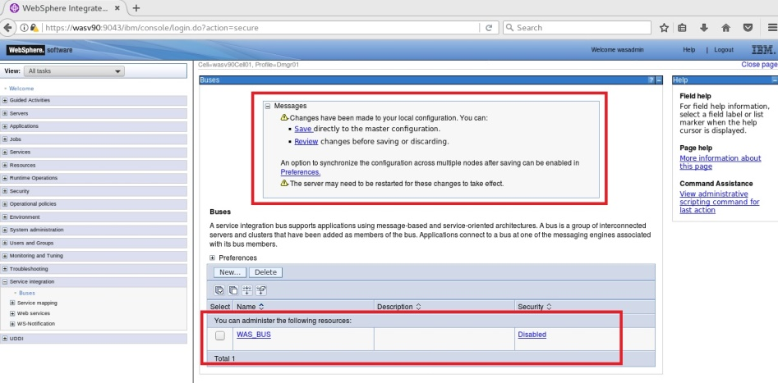

**Task 1 is complete!**

**Task 2: Create JMS Factory**

Create SIB

Connect. Factory

BUS member

JMS Dest.

JMS Queue



JMS   
AP

**Step 1:** Navigate to “Resources>JMS>Connection factories” and then select the scope you want to add a connection factory.

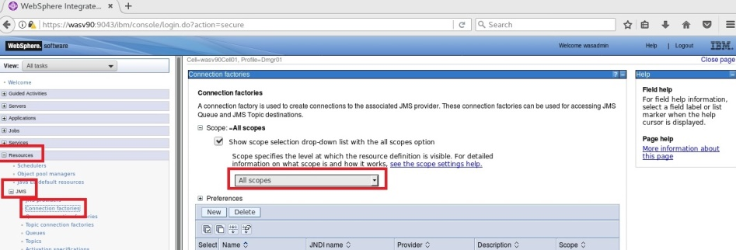

**Step 2:** In this example, we choose the cell as scope and then click “Next”.

Create SIB

Connect. Factory

BUS member

JMS Dest.

JMS Queue



JMS   
AP

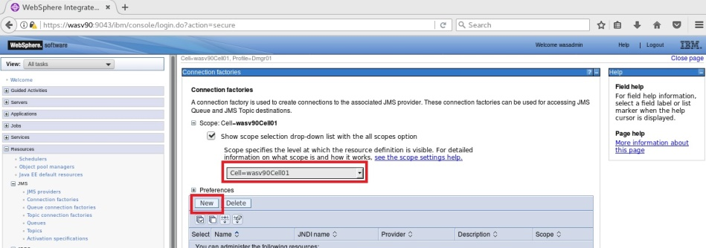

**Step 3:** Select “Default messaging provider” and then click “OK”. You can choose “WebSphere MQ messaging provider” for WebSphere MQ configuration.

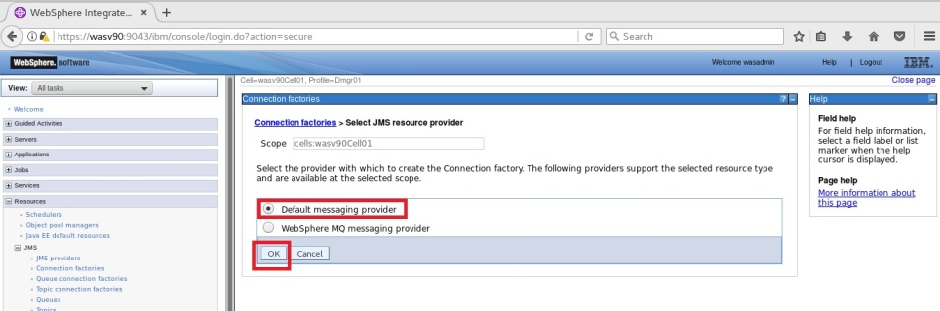

**Step 4:** You need to define name and JNDI name for the default messaging provider connection factory.

Create SIB

Connect. Factory

BUS member

JMS Dest.

JMS Queue



JMS   
AP

*Name: WASV90JMSCF*

*JDNI name: jms/WASV90JMSCF*

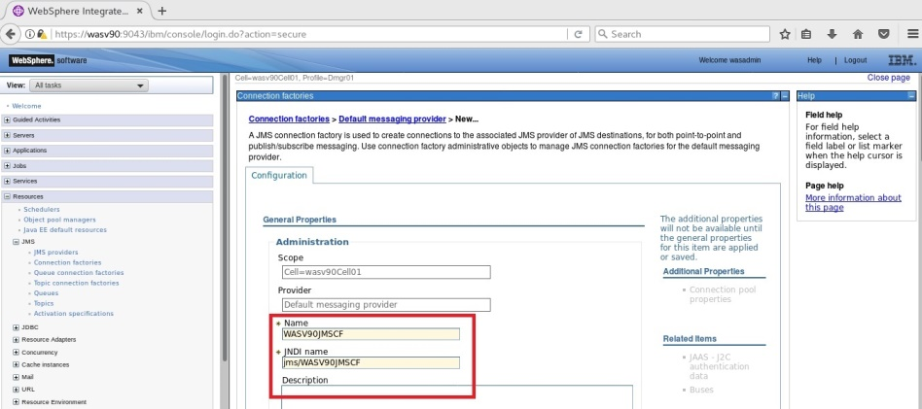

Create SIB

Connect. Factory

BUS member

JMS Dest.

JMS Queue



JMS   
AP

Scroll down to select “Bus name” that we added in the first task.

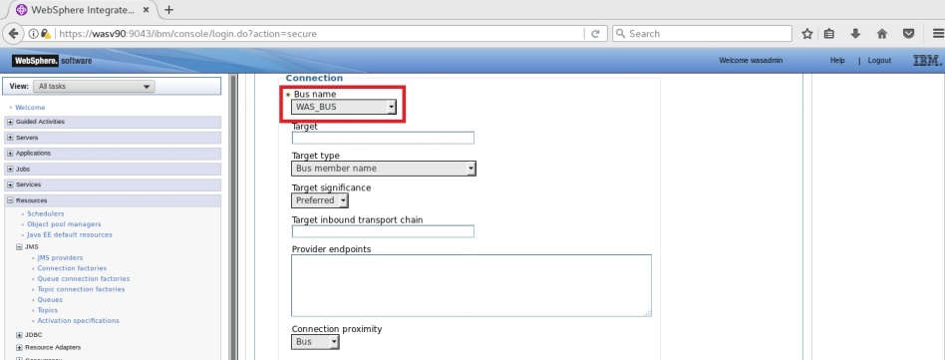

ScrollS

Create SIB

Connect. Factory

BUS member

JMS Dest.

JMS Queue



JMS   
AP

Scroll down and click “OK”.

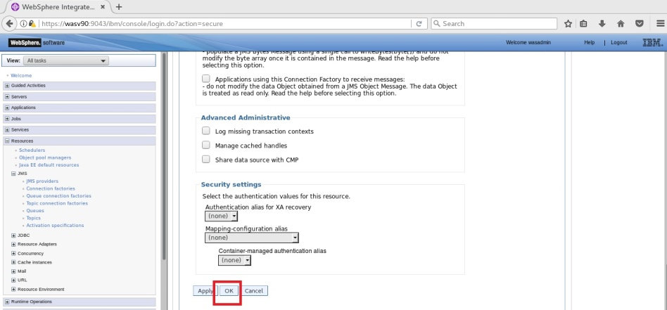

Create SIB

Connect. Factory

BUS member

JMS Dest.

JMS Queue



JMS   
AP

**Step 5:** Click on “Save” to write changes directly to master configuration.

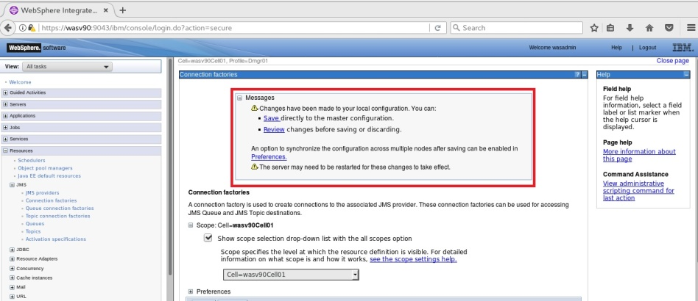

You should see the newly added connection factory.

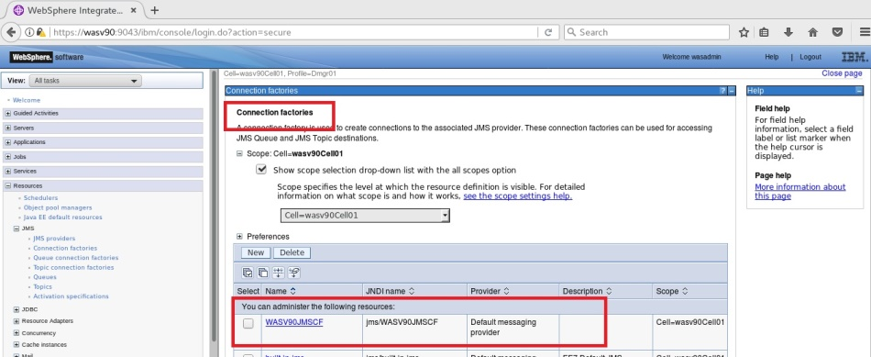

**Task 2 is complete!**

Create SIB

Connect. Factory

BUS member

JMS Dest.

JMS Queue



JMS   
AP

**Task 3: Add a Bus member**

**Step 1:** Navigate to “Service integration>Buses” and click on the bus name (WAS_Bus) to change parameters.

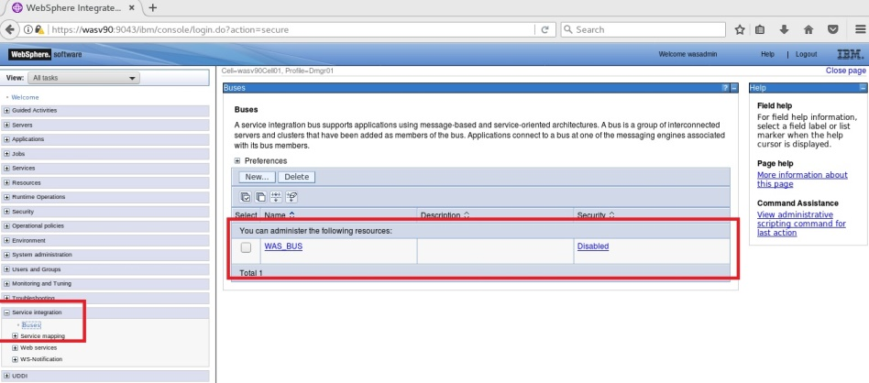

Create SIB

Connect. Factory

BUS member

JMS Dest.

JMS Queue



JMS   
AP

**Step 2:** Click on “Bus members” under “Topology” menu located on the right.

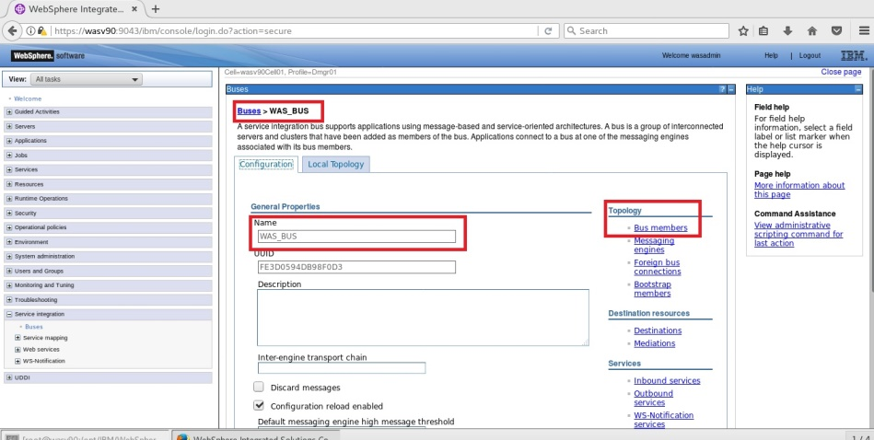

Create SIB

Connect. Factory

BUS member

JMS Dest.

JMS Queue



JMS   
AP

**Step 3:** Click on “Add” to define a member to the bus.

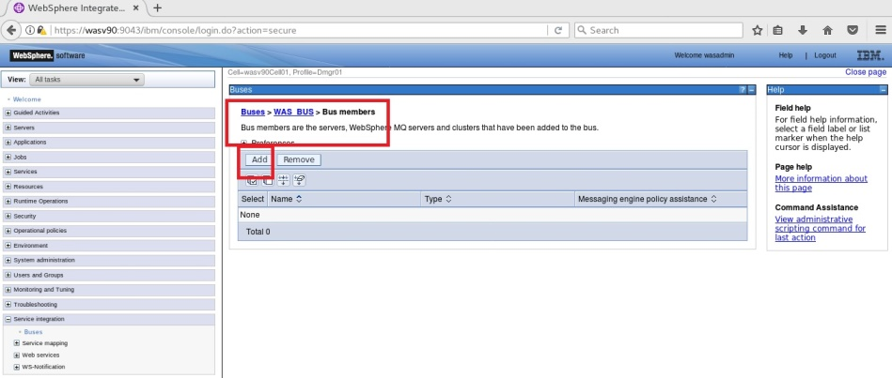

**Step 4:** Select “Server” or “Cluster” according to your needs and then click on “Next”.

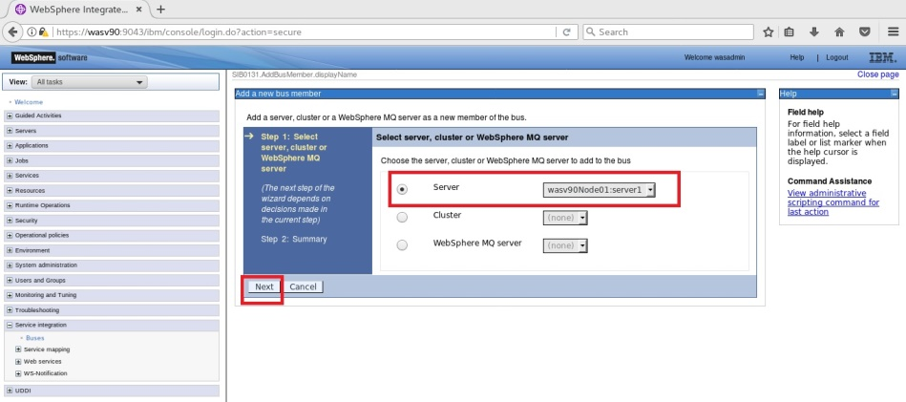

Create SIB

Connect. Factory

BUS member

JMS Dest.

JMS Queue



JMS   
AP

**Step 5:** Select “File store” and then click “Next”.

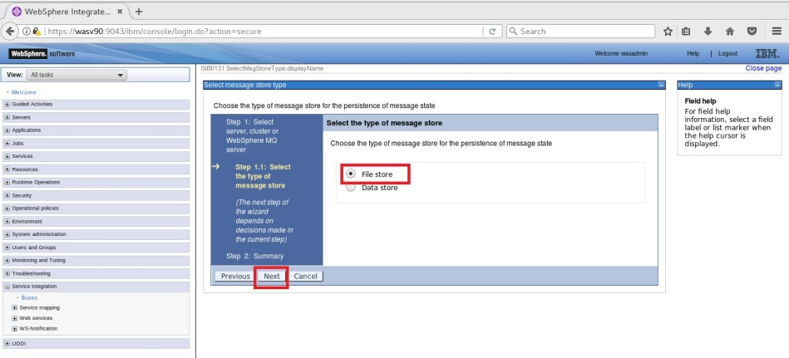

Create SIB

Connect. Factory

BUS member

JMS Dest.

JMS Queue



JMS   
AP

**Step 6:** Configure the properties for the file store and then click “Next”.

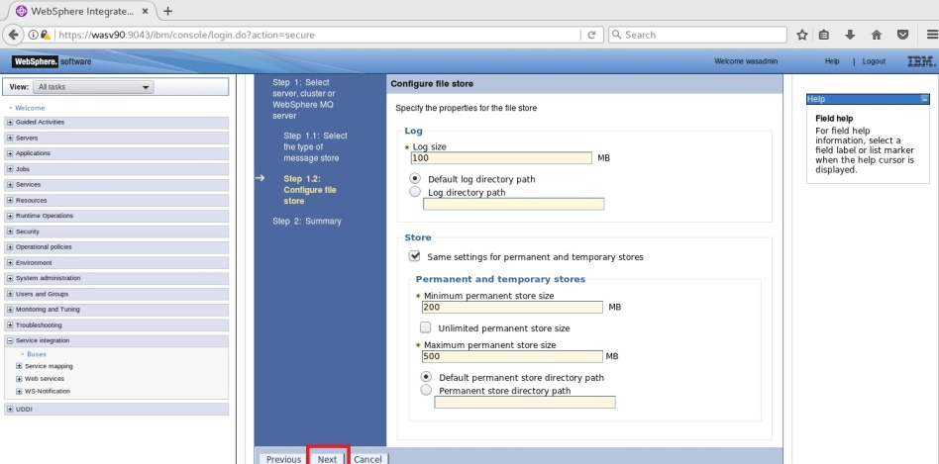

Create SIB

Connect. Factory

BUS member

JMS Dest.

JMS Queue



JMS   
AP

**Step 7:** You can tune the application server for messaging performance selecting the

option “Change heap sizes” and then click “Next”.

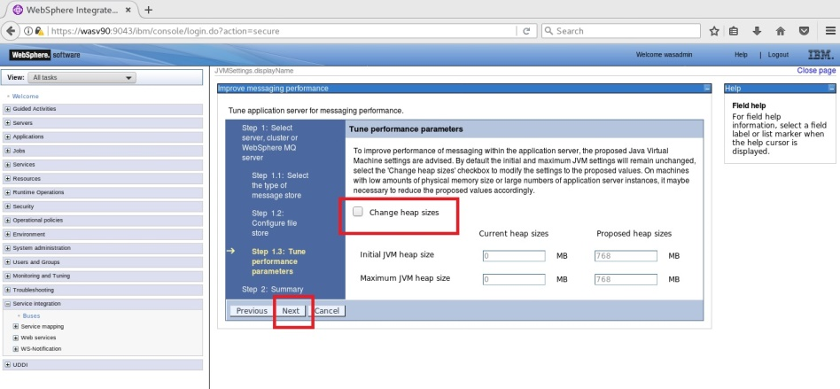

**Step 8:** Review the summary of actions and then click “Finish”.

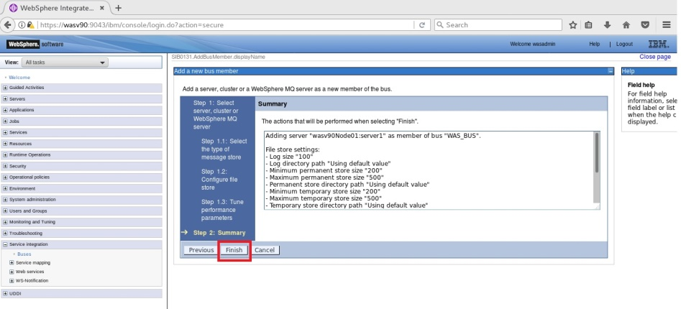

Create SIB

Connect. Factory

BUS member

JMS Dest.

JMS Queue



JMS   
AP

**Step 9:** Click on “Save” to write changes to the master configuration.

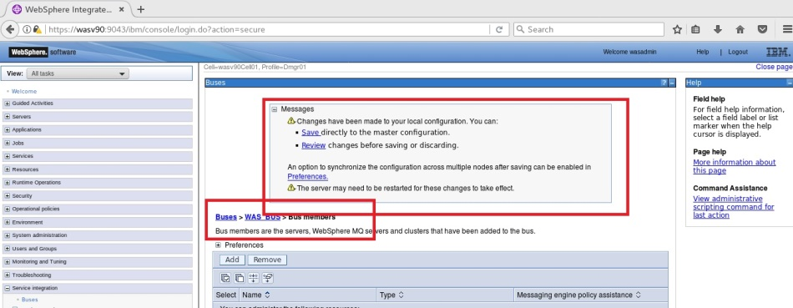

You should be able to see the bus member we just added as follows.

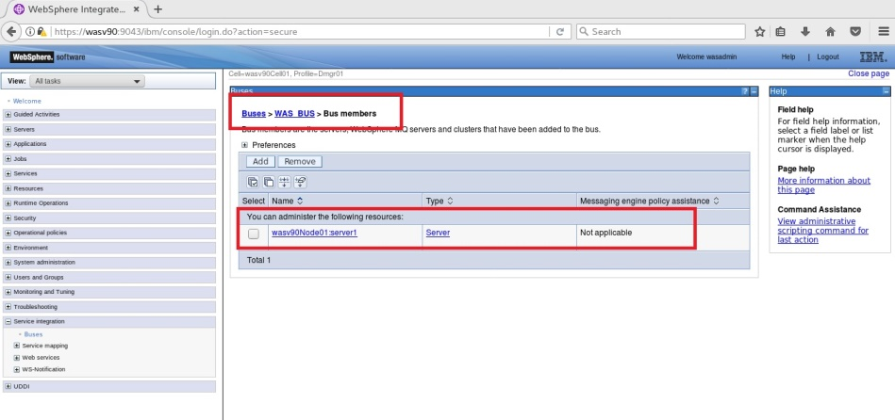

**Task 3 is complete!**

Create SIB

Connect. Factory

BUS member

JMS Dest.

JMS Queue



JMS   
AP

**Task 4: Configure JMS Destination**

**Step 1:** Navigate to “Service integration>Buses” and click on the bus name.

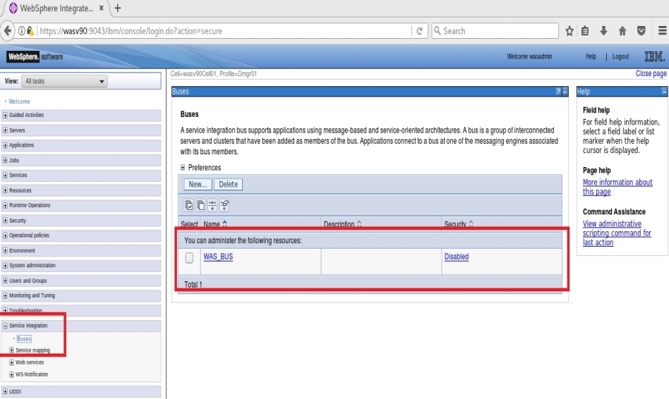

Create SIB

Connect. Factory

BUS member

JMS Dest.

JMS Queue



JMS   
AP

**Step 2:** Click on “Destinations” under “Destination resources” menu located on the right.

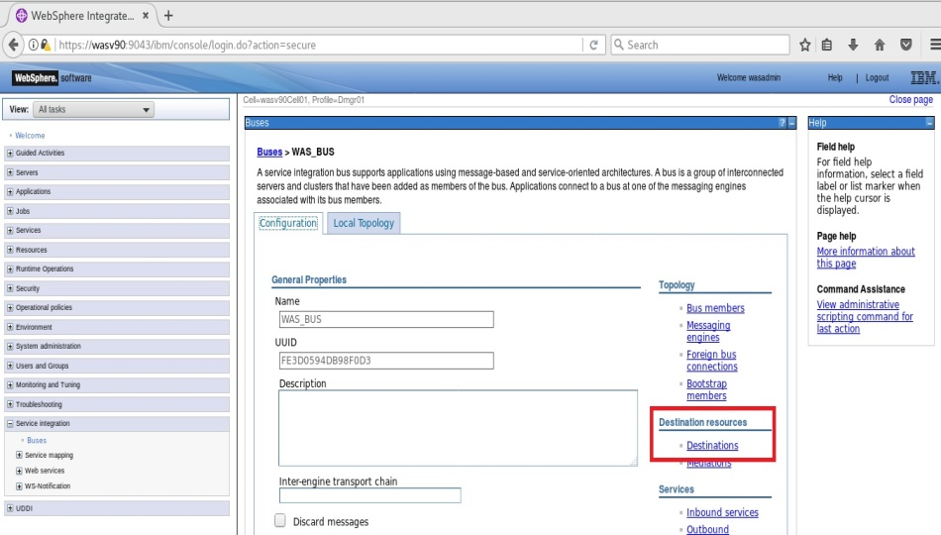

Create SIB

Connect. Factory

BUS member

JMS Dest.

JMS Queue



JMS   
AP

**Step 3:** Click on “New” to add a new destination.

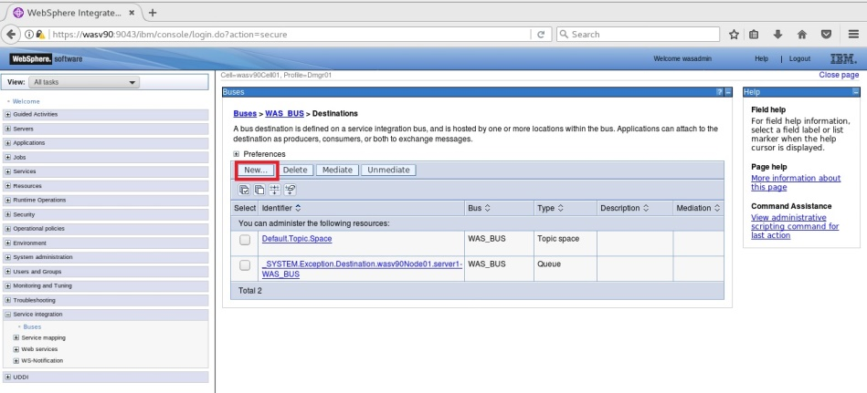

**Step 4:** Select the destination type “Queue” and click “Next”.

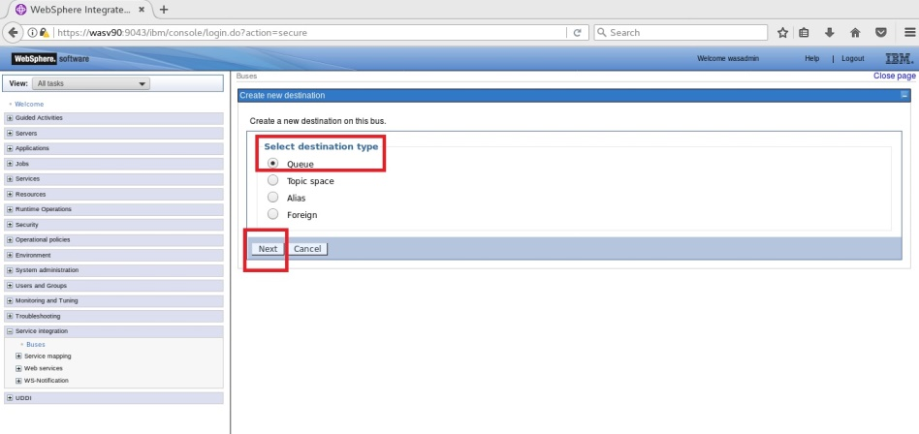

Create SIB

Connect. Factory

BUS member

JMS Dest.

JMS Queue



JMS   
AP

**Step 5:** Enter an identifier for the new queue and click “Next”. (WAS_JMSdestQueue)

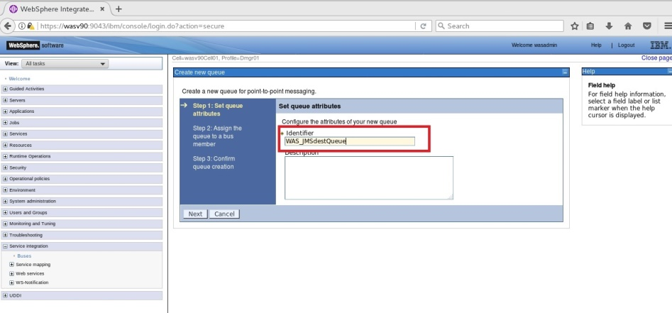

**Step 6:** Click on “Next”.

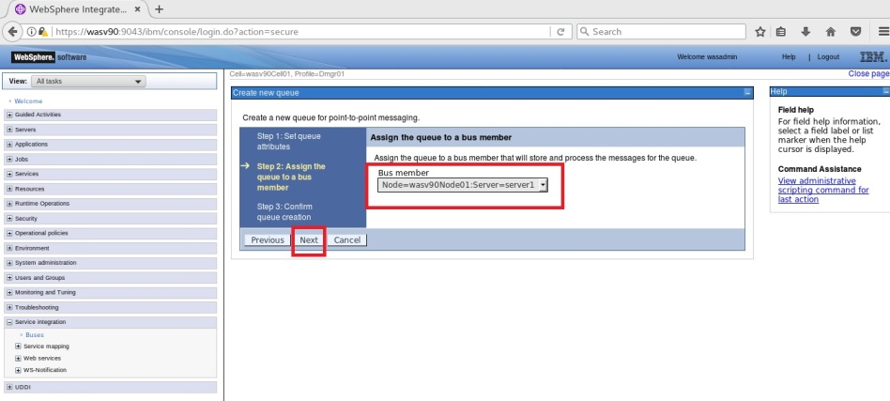

Create SIB

Connect. Factory

BUS member

JMS Dest.

JMS Queue



JMS   
AP

**Step 7:** Review the summary of actions and click “Finish”.

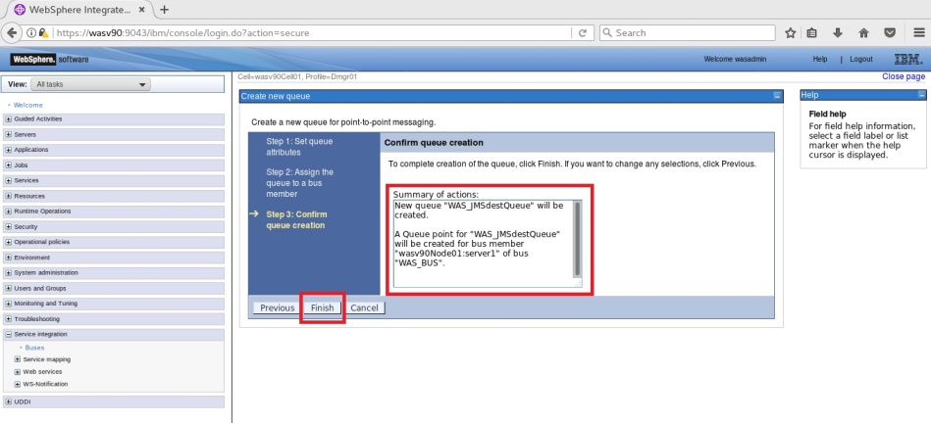

Create SIB

Connect. Factory

BUS member

JMS Dest.

JMS Queue



JMS   
AP

**Step 8:** Click on “Save” to write changes directly to the master configuration.

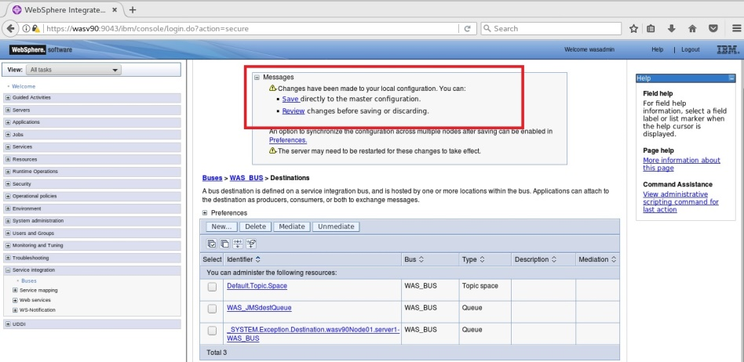

You should see the newly added destination queue listed.

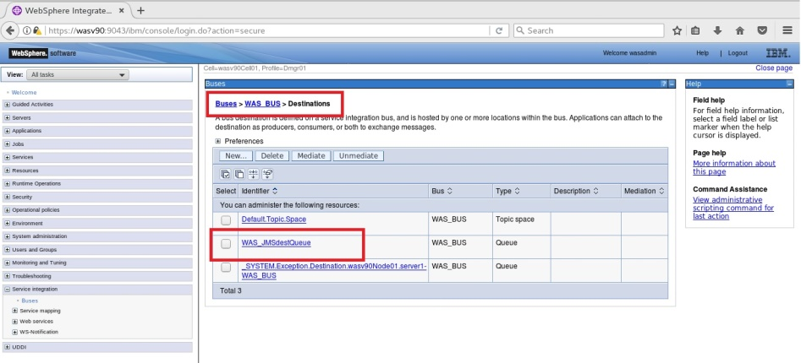

**Task 4 is complete!**

Create SIB

Connect. Factory

BUS member

JMS Dest.

JMS Queue



JMS   
AP

**Task 5: Configure JMS queue**

**Step 1:** Navigate to “Resources>JMS>Queues” and select the scope of the definition.

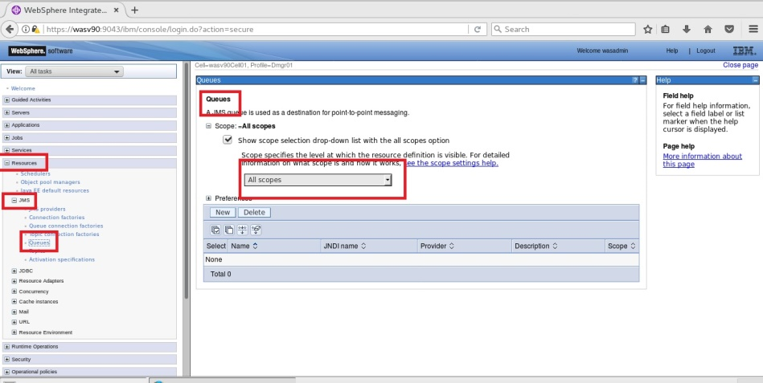

Create SIB

Connect. Factory

BUS member

JMS Dest.

JMS Queue



JMS   
AP

**Step 2:** Click “New” to start.

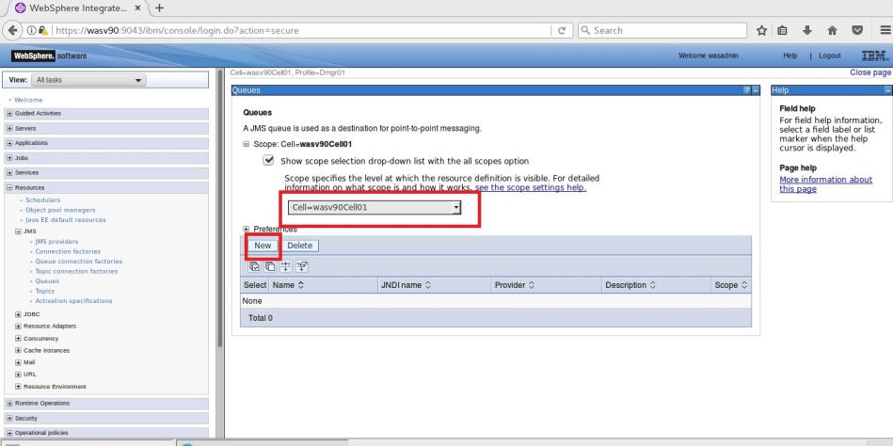

**Step 3:** Select “Default messaging provider” and then click “OK”.

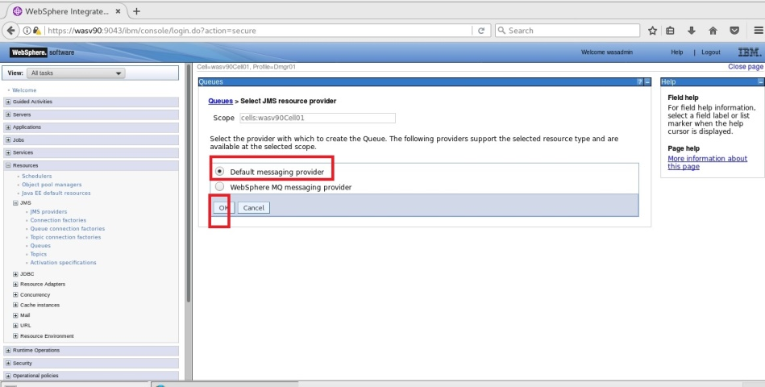

Create SIB

Connect. Factory

BUS member

JMS Dest.

JMS Queue



JMS   
AP

**Step 4:** Enter “Name” and “JNDI name”.

*Name: WASJMSqueue*

*JNDI name: jms/WASJMSqueue*

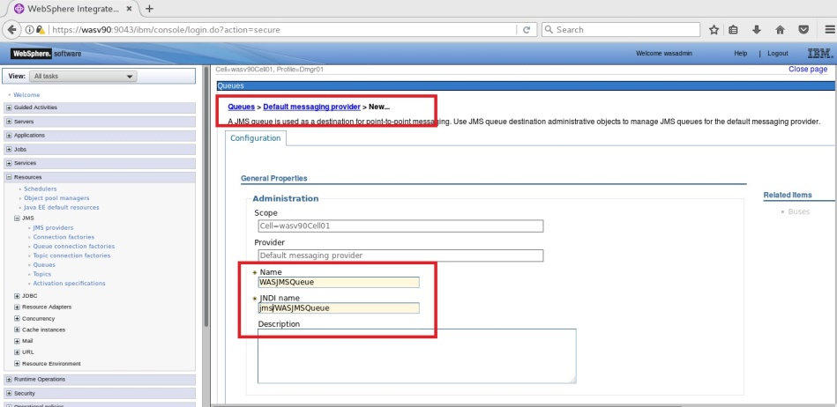

Create SIB

Connect. Factory

BUS member

JMS Dest.

JMS Queue



JMS   
AP

Select the “Bus name” and “Queue name” values we added in previous tasks.

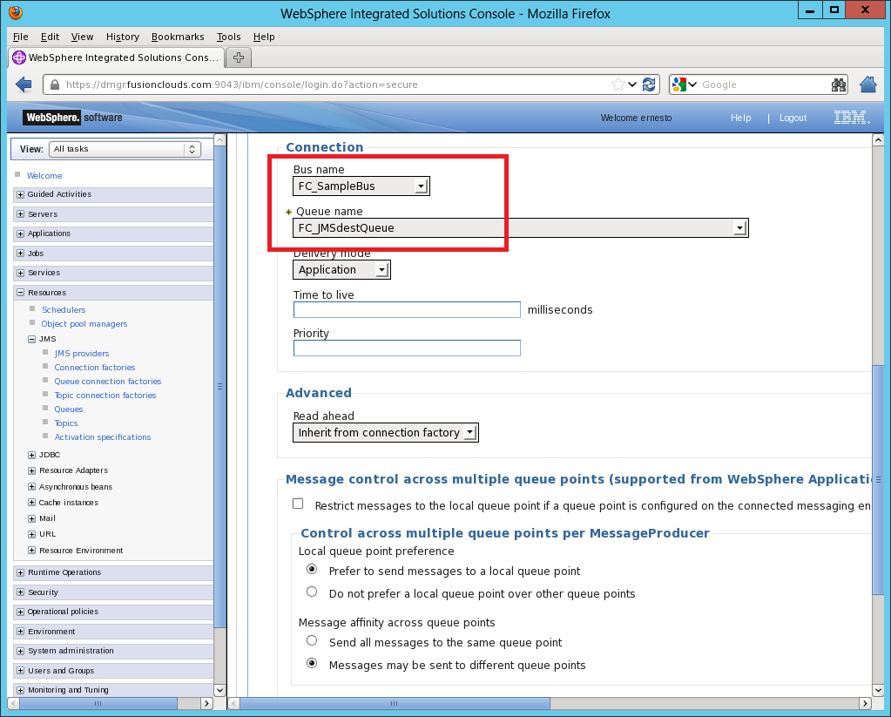

Create SIB

Connect. Factory

BUS member

JMS Dest.

JMS Queue



JMS   
AP

Click on “OK” to continue.

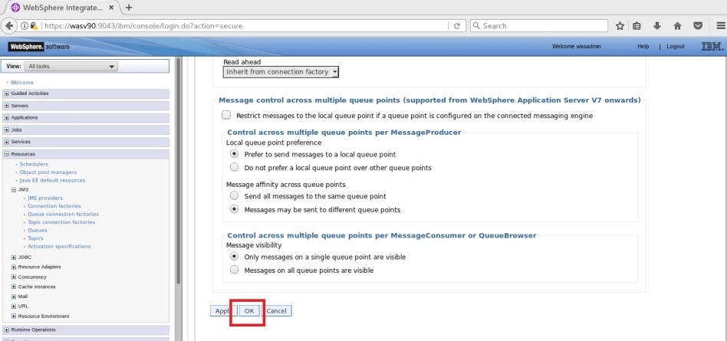

Create SIB

Connect. Factory

BUS member

JMS Dest.

JMS Queue



JMS   
AP

**Step 5:** Click “Save” to write changes to master file.

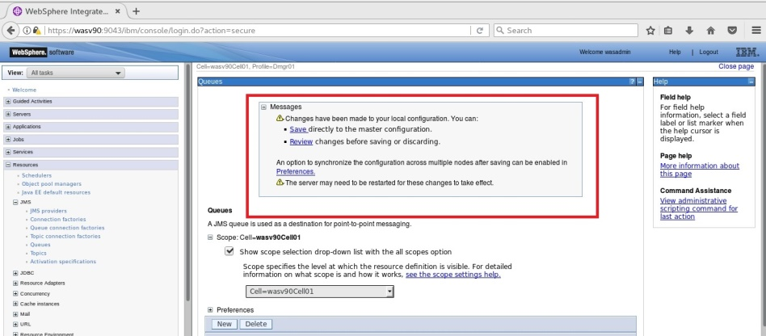

You should be able to see the newly added queue.

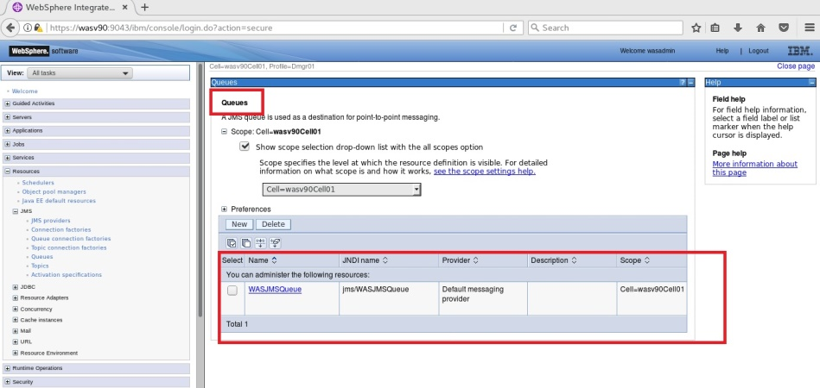

**Task 5 is complete!**

Create SIB

Connect. Factory

BUS member

JMS Dest.

JMS Queue



JMS   
AP



**Task 6: Configure JMS Activation Specifications**

**Step 1:** Navigate to “Resources>JMS>Activation specifications” and select your scope you want to define.

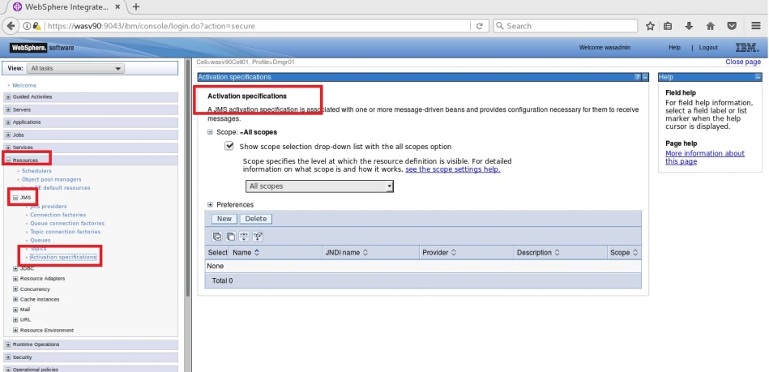

Create SIB

Connect. Factory

BUS member

JMS Dest.

JMS Queue



JMS   
AP



**Step 2:** Click on “New” to start definition.

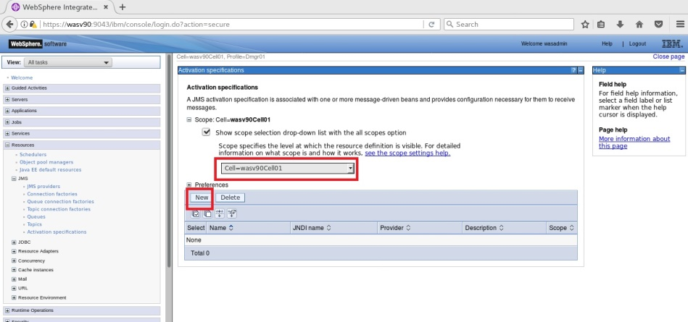

**Step 3:** Select “Default messaging provider” and click “OK”.

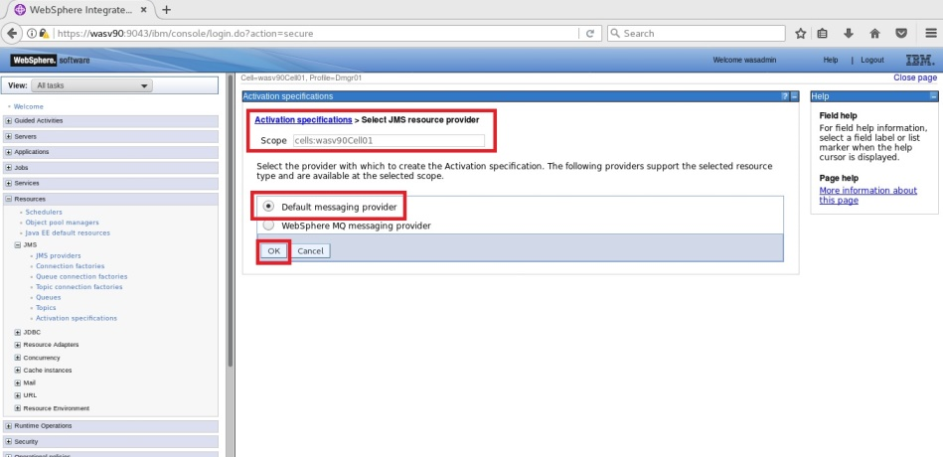

Create SIB

Connect. Factory

BUS member

JMS Dest.

JMS Queue



JMS   
AP



**Step 4:** Define “Name” and “JNDI name”.

*Name: WASJMSas  
JDNI name: jms/WASJMSas*

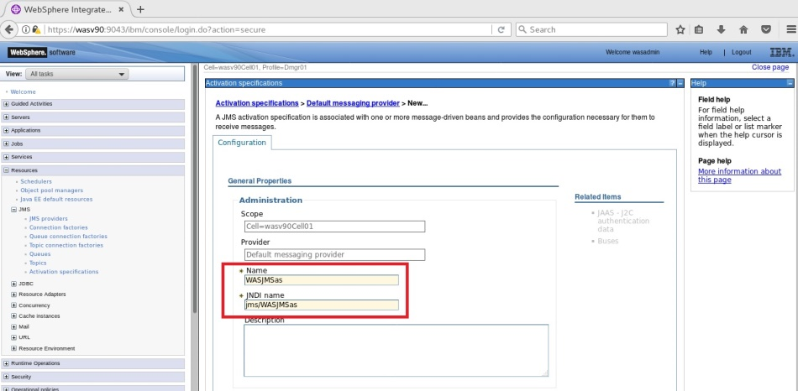

Create SIB

Connect. Factory

BUS member

JMS Dest.

JMS Queue



JMS   
AP



Select “Destination type” as “Queue”, for “Destination JNDI name” enter “jms/WASJMSqueue” and select “Bus name” as “WAS_Bus”.

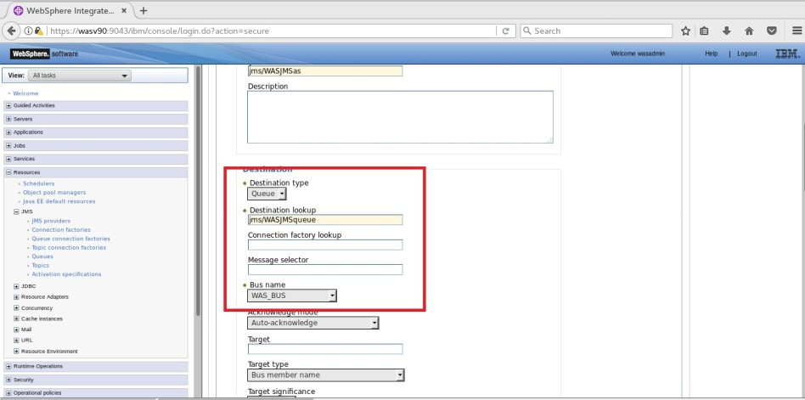

Create SIB

Connect. Factory

BUS member

JMS Dest.

JMS Queue



JMS   
AP



Scroll down and click “OK”.

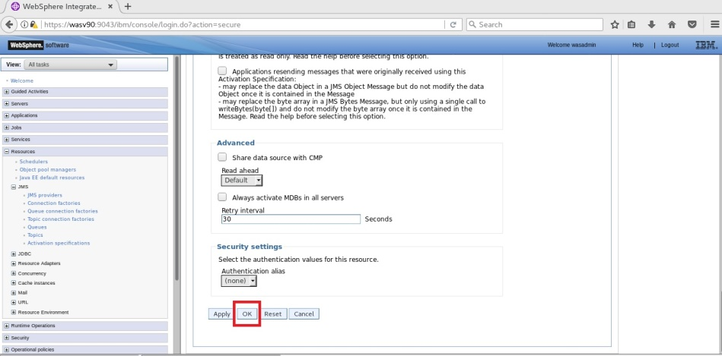

Create SIB

Connect. Factory

BUS member

JMS Dest.

JMS Queue



JMS   
AP



**Step 5:** Click on “Save” to write changes to the master configuration.

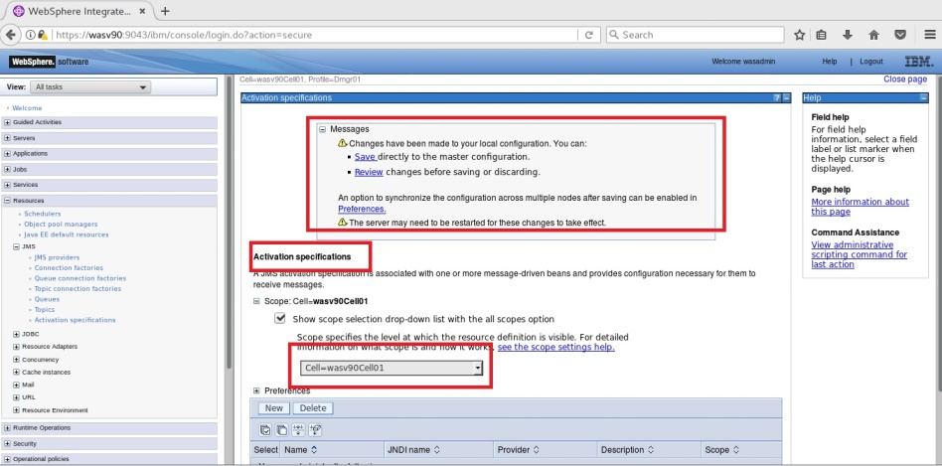

You should see the newly added activation specification listed.

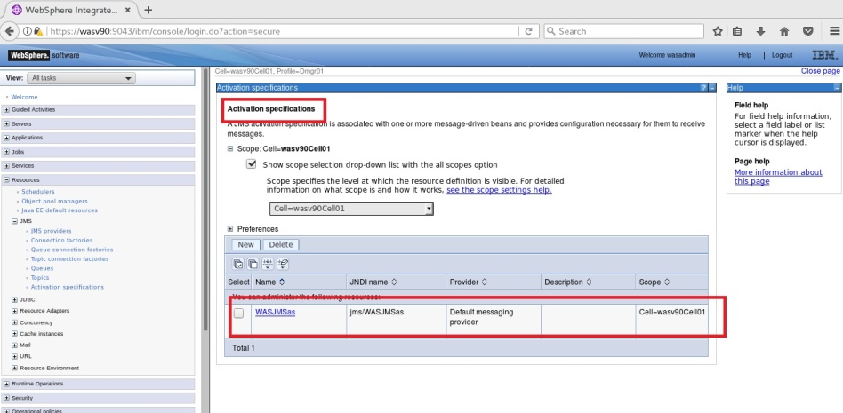

**Task 6 is complete!**

# SUMMARY

WebSphere Application Server supports asynchronous messaging that allows to create, send, receive and read requests between applications. For this communication, you need to configure different components of JMS depending on your application. WebSphere can work with default messaging provider, or with WebSphere MQ or with many other messaging software.

# REFERENCES

* http://pic.dhe.ibm.com/infocenter/tivihelp/v50r1/index.jsp?topic=%2Fcom.ibm.mbs.doc%2Ffm_sag%2Fconfigsys%2Fc_jms_config_websphere.html
* http://pic.dhe.ibm.com/infocenter/prodconn/v1r0m0/index.jsp?topic=%2Fcom.ibm.scenarios.wmqwas101.doc%2Ftopics%2Fins_wascfg.htm

# INDEX

Asynchronous messaging 235

connection factory 236

EJB 237

Java Message Service (JMS) 235

JMS activation specification 237

JMS destination 236

MDB 237

service integration bus 236

Synchronous messaging 235

XML 236